PETROLEUM AND CRUDE OIL

BEHAVIOUR OBJECTIVES
At the end of this lesson, students should be able to:
- discuss the origin and composition of crude oil.
- itemize crude oil reserves in the world and Nigeria.
- explain exploration and drilling of crude oil in Nigeria.
- expound fractional distillation of crude oil, list 7 products obtained and state their uses.
- explain petroleum cracking and reforming, octane number rating and anti-knocking agents.
- discuss the economic importance of crude oil/petroleum.
- define petrochemicals and discuss its use as starting materials of organic synthesis.
- explain occurrence and packaging of natural gas as LNG.

PETROLEUM
A natural occurring dark, sticky, viscous liquid with unpleasant smell. It is a mixture of hydrocarbons (alkanes, alkenes, cycloalkanes, aromatic hydrocarbons) that found on earth in liquid, gaseous, or solid form. It is formed from the decay of marine organisms that died millions of years ago. Petroleum is a natural resource found in a number of countries around the world. World reserves include Nigeria, Saudi-Arabia, Canada, Venezuela, Kuwait, Iran, U.S.A, Libya, Iraq, etc.

NIGERIA RESERVES
Petroleum is a natural resource in Nigeria found in Bayelsa State, Rivers State, Delta State, Abia State, Akwa-Ibom State, Imo State, Edo State, Ondo State, etc.

EXPLORATION AND DRILLING OF CRUDE OIL
Exploration is the process of examining places where abundant oil potentially exists under the earth’s surface. This is done by exploding a dynamite in deep holes in the earth’s crust and recording the reflections of the shock waves from the rock layers using Seismometers. The information on the seismogram is then used to detect possible oil-bearing areas.
Crude oil is extracted by drilling deep holes or wells into the ground. The drilling is done by a rotary rig supported by a derrick. When the well reaches an oil-bearing layer, the crude oil then shoots up into the air under high pressure. It is then stored in large steel tanks until it is sent to oil refiners by super-tankers or pipeline.

FRACTIONAL DISTILLATION OF CRUDE OIL
Crude oil is not a single compound but a complex mixture of hydrocarbons. So, there is a need for separation. The main operations of refining crude oil are separation, purification, conversion. The first step is commonly referred to as Fractional Distillation, it is the separation of crude oil into different fractions using the fractional tower of the oil refinery.
The crude oil is pre-heated in an electric furnace to about 400ºC. then the mixture of hot vapour and liquid flows through pipes to the fractionating tower. As the vapour containing the mixture ascends the tower, it cools, condenses and separates out into several fractions according to the volatility of the substances in the mixture. Substances with higher boiling points separate out in the tray a on the lower part of the tower, while those with lower boiling points separate out on the trays in the upper part of the tower. In this way, different fractions are drawn off at different heights on the column, then redistilled to improve purity and eventually treated to obtain different liquid fuels and petrochemicals.

FRACTIONS OF CRUDE OIL
The principal fractions are;
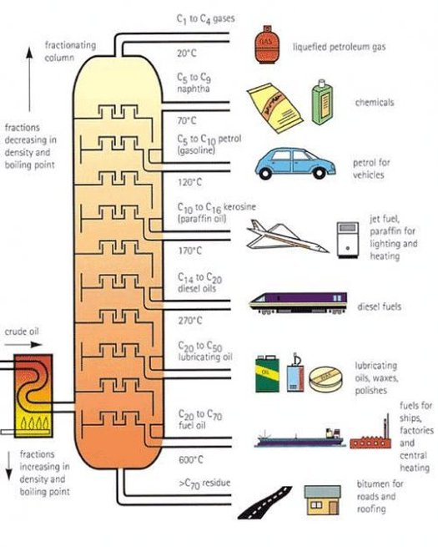
Fractions | Temperature Range | Uses
Petroleum gas  (C₁ – C₄)  Petroleum ether  (C₅ -C₇)  Petrol  Kerosene  C₁₂ – C₁₈  Diesel oil  C₂₀ – C₂₅  Lubricating oils  >C₂₀  Bitumen  >C₃₅ | Below 40ºC  2ºC – 60ºC  40ºC – 200ºC  200ºC – 250ºC  250ºC – 350ºC  350ºC – 500ºC  Above 500ºC | As fuels in homes and industries.  As organic solvents.  Fuel for motor vehicles and aeroplanes.  Fuel for lighting, heating, tractors and modern jets.  Fuel for diesel engines and for cracking process.  Lubricating moving parts of engines and machines.  In paving roads airfields.

LOCATION OF REFINERIES IN NIGERIA
- Warri Refinery and Petrochemical plant in Delta State
- New port Harcourt refinery in Rivers State
- Defunct Kaduna Refinery in Kaduna State
- Dangote Refinery in Lagos State

CRACKING AND REFORMING OF PETROLEUM FRACTIONS
Cracking is a process whereby large and complex hydrocarbon fractions are broken down into smaller and lighter fractions. It involves heating the hydrocarbons in the C₁₅ – and higher range under high pressure to decompose them to smaller molecules.
It is more economical to undergo cracking since it is only the low molecular mass hydrocarbons that are mostly used as fuels and raw materials in the chemical industry due to its commercial value.
There are two types of cracking – thermal cracking and catalytic cracking. The first involves very high temperature (above 1000ºC) while the other involves the use of catalyst (e.g. finely silica alumina, aluminium oxide).

REFORMING
The catalytical conversion of straight chain hydrocarbons to branched chain and cyclic hydrocarbons by heating the petroleum fraction in the presence of oxide of silicon as catalyst at about 600ºC and at 12 atm. This process is to improve the quality of petrol from low grade petrol to higher grade petrol by increasing the fraction’s octane number.

OCTANE NUMBER/RATING
Octane number/rating is a value that indicates how smoothly petrol burns in the engine of a vehicle. It measures the performance of fuel for a combustion engine. The rating depends on the percentage composition of branched chain (iso-octane) to straight chain (n-heptane) hydrocarbons in the fuel.
High-grade petrol has an octane rating closer to 100 while low grade petrol has an octane number around 0, which causes knocking of the motor engines. This reduces the efficiency of the engine as well as shortens its life span.

ANTI-KNOCKING AGENTS
When petrol with high proportion of heptane is used in the engine of a vehicle, the combustion will not be smooth and can lead to knocking of the engine. i.e. the higher the octane number of petrol, the lower the knocking tendency.
In order to increase the octane number, an addictive is added to petrol. It is called antiknock, e.g. tetraethyl lead (IV), Pb(C₂H₅)₄.

ECONOMIC IMPORTANCE OF CRUDE OIL/PETROLEUM
- It is a major source of energy, generating heat and powering to various types of vehicles and machinery.
Petrochemical industry uses petroleum as a raw material to make products such as plastics, paints, cosmetics.
- Source of nation's revenue.
- Creation of jobs.
- By-products of fractional distillation of petroleum are used in the surfacing of roads, construction of bridges, etc.

NATURAL GAS
Natural gas is a mixture of low molecular mass of alkanes and other gases. It is found in the earth’s crust trapped with petroleum. Natural gas consists of 60%-90% methane with ethane, propane, and butane present in smaller quantities. Nitrogen, carbon(IV)oxide, hydrogen sulphide, and helium are also present in smaller quantities.
The earth has enormous quantities of natural gas, but much of it is in areas far from where the gas is needed. To move this cleaner burning fuel across oceans, natural gas is converted to liquefied natural gas (LNG), this process is called Liquefaction.

PROCESS
Natural gas is liquefied under pressure to obtain liquefied natural gas, (LNG). LNG is a colourless, odourless, non-toxic gas. It burns completely leaving no ash and no carbon monoxide, CO_{(g)}, and so it is considered as a valuable fuel.

USES OF LIQUEFIED NATURAL GAS
- As domestic and industrial fuel.
- As transportation fuel in special engines.
- Used in production of synthetic gas.
- Source of hydrogen and carbon.

PETROCHEMICALS
Petrochemicals are substances manufactured from petroleum products. They are not directly produced from petroleum. For instance, ethanol is a petrochemical and the chain of production is; Crude oil $\underset{→}{ fractional distillation }$ Petroleum products $\underset{→}{ cracking }$ Ethene $\underset{→}{ Hydration }$ Ethanol
Other examples are ethanol, ethene, propane 1,2,3-triol, benzene, toluene, etc. They serve as raw materials for the production of some organic compounds like plastics, synthetic rubber, soaps, nylon, dyes, detergents, tires, paints, etc.

DRILL QUESTIONS

- The proportion of petrol obtainable from crude oil can be increased by ……………?
- Condensing lighter fractions
- Distilling heavier fractions
- Cracking heavier fractions
- Hydrogenating lighter fractions

- Which of the following is not a fraction of petroleum?
- Kerosene
- Sulphur
- Petrol
- Bitumen

- What method is often employed in the separation of the hydrocarbons found in petroleum?
- Catalytic cracking
- Polymerization
- Fractional distillation
- Hydrogenation

- The separation of petroleum fractions depends on the differences in ……...........?
- Boiling points
- Melting points
- Molar masses
- Solubilities

- Fractional distillation involves the following processes …………….?
- Boiling
- Boiling and condensation
- Condensation and collection
- Boiling, evaporation and condensation

ANSWER
- C
- B
- C
- A
- D

